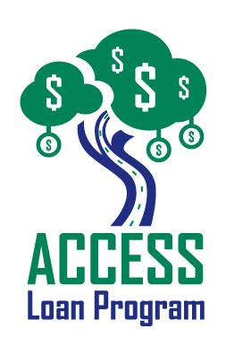

MISSION STATEMENT

Commerce Lexington Acce$$ Loan Program’s mission is to provide easier access to the financing and helpful business advice that you need to start or grow your business.

This program is committed to fostering economic growth and enhancing business opportunities for minorities, women, and small businesses.

WHAT IS ACCE$$?

Commerce Lexington and Lexington’s leading banks and financial institutions have teamed up in the Acce$$ Program to improve your odds of getting approval for a loan that matches your business needs. There are no guarantees, but you will know what your chances are of securing the credit you desire.

The program will provide valuable feedback from experts from the lending community to assist you in putting together a business plan on gathering information that is so important to your success.

QUALIFICATIONS

- The ACCESS Loan Program is expanding beyond the Greater Lexington Area.

(Current partners include entities in the following counties: Bourbon, Clark, Jessamine, Madison, Scott, Harrison, Boyle, Franklin, & Woodford Counties. These counties act as hubs for six additional counties.)

- Your business must be for profit.

- Pursuing a loan for business start-up, an expansion of your current business, the purchase of a franchise, or the purchase of an existing business.

- The minimum loan amount is $5,000.

- Use of funds must be for: working capital, inventory, leasehold improvements, or equipment (for commercial use only).

- SBA personal Financial Statement.

HOW TO APPLY

- Loan packages may be obtained at Commerce Lexington. (Completed applications should be returned to Commerce Lexington).

- Business planning assistance is available at no charge through the Lexington Area Small Business Development Center (SBDC). Call 257-7666 or toll free at 1-888-475-SBDC to schedule an appointment.

- All information provided to the Acce$$ Committee and Commerce Lexington will be kept strictly confidential.

LOAN CHECKLIST*

- Acce$$ Loan Review Data Sheet

- Personal Financial Statement

- Tax Returns for the last 3 years (Business & Personal)

- Business Plan

- Sources & Use Document

- Marketing Plan

- Financial Projections- 3 years

- Resume

*Please return loan package with the following completed information and in this order. Incomplete packages will not be processed.

ACCESS LOAN PROGRAM

PARTICIPATING ENTITIES

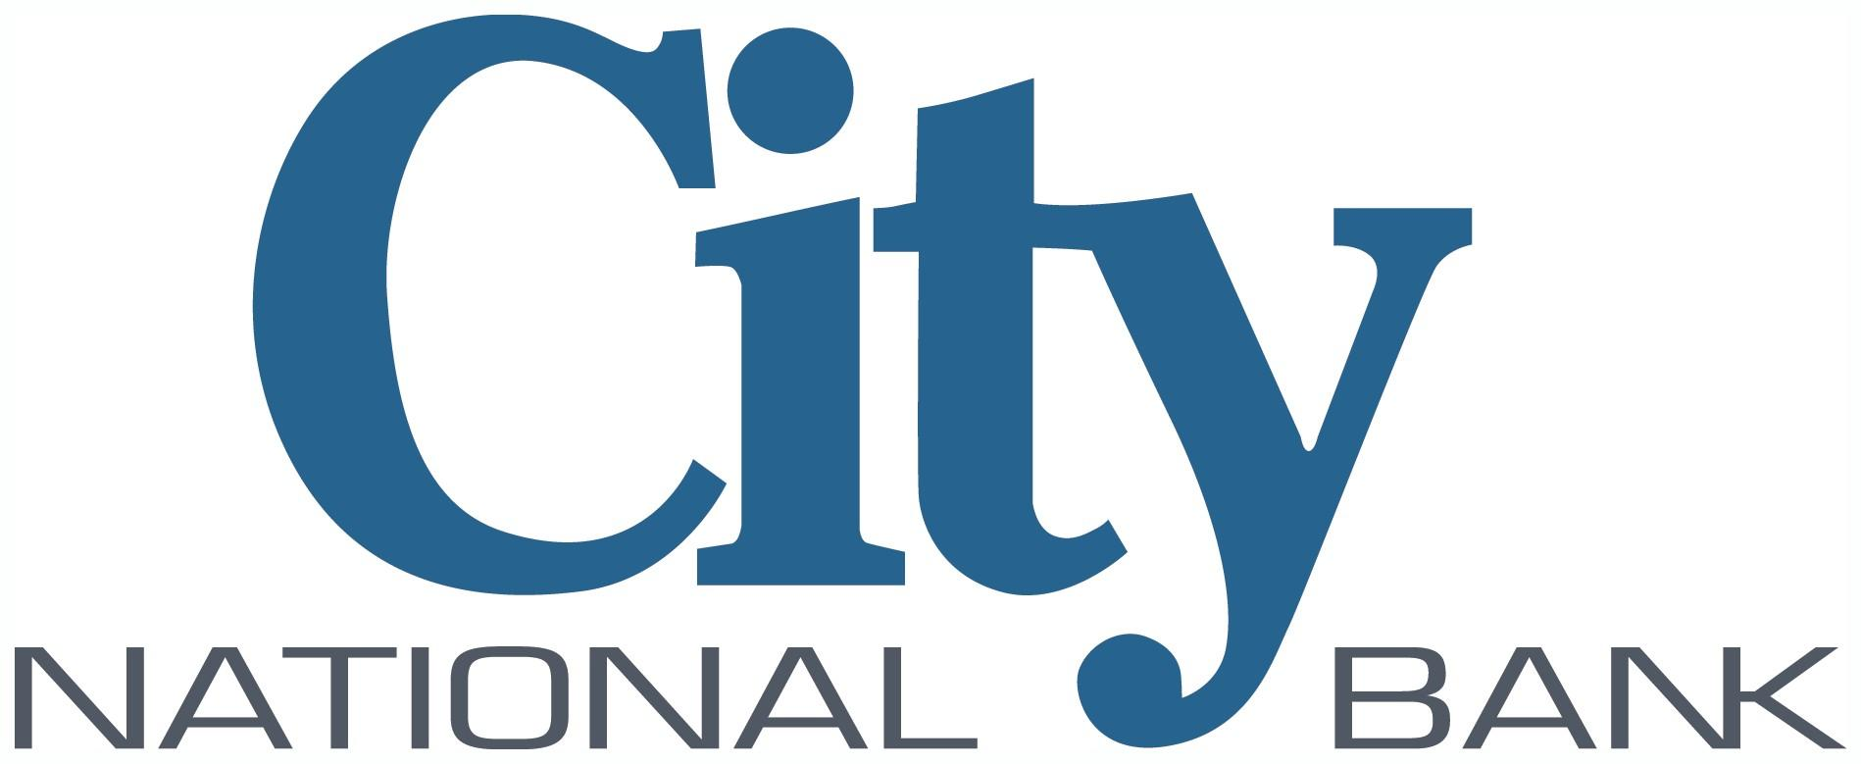

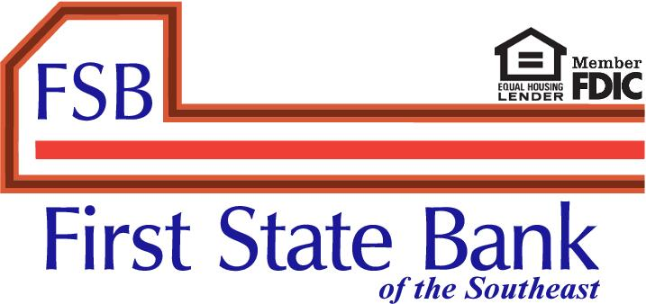

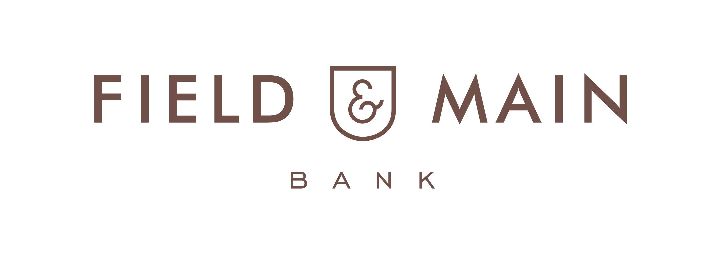

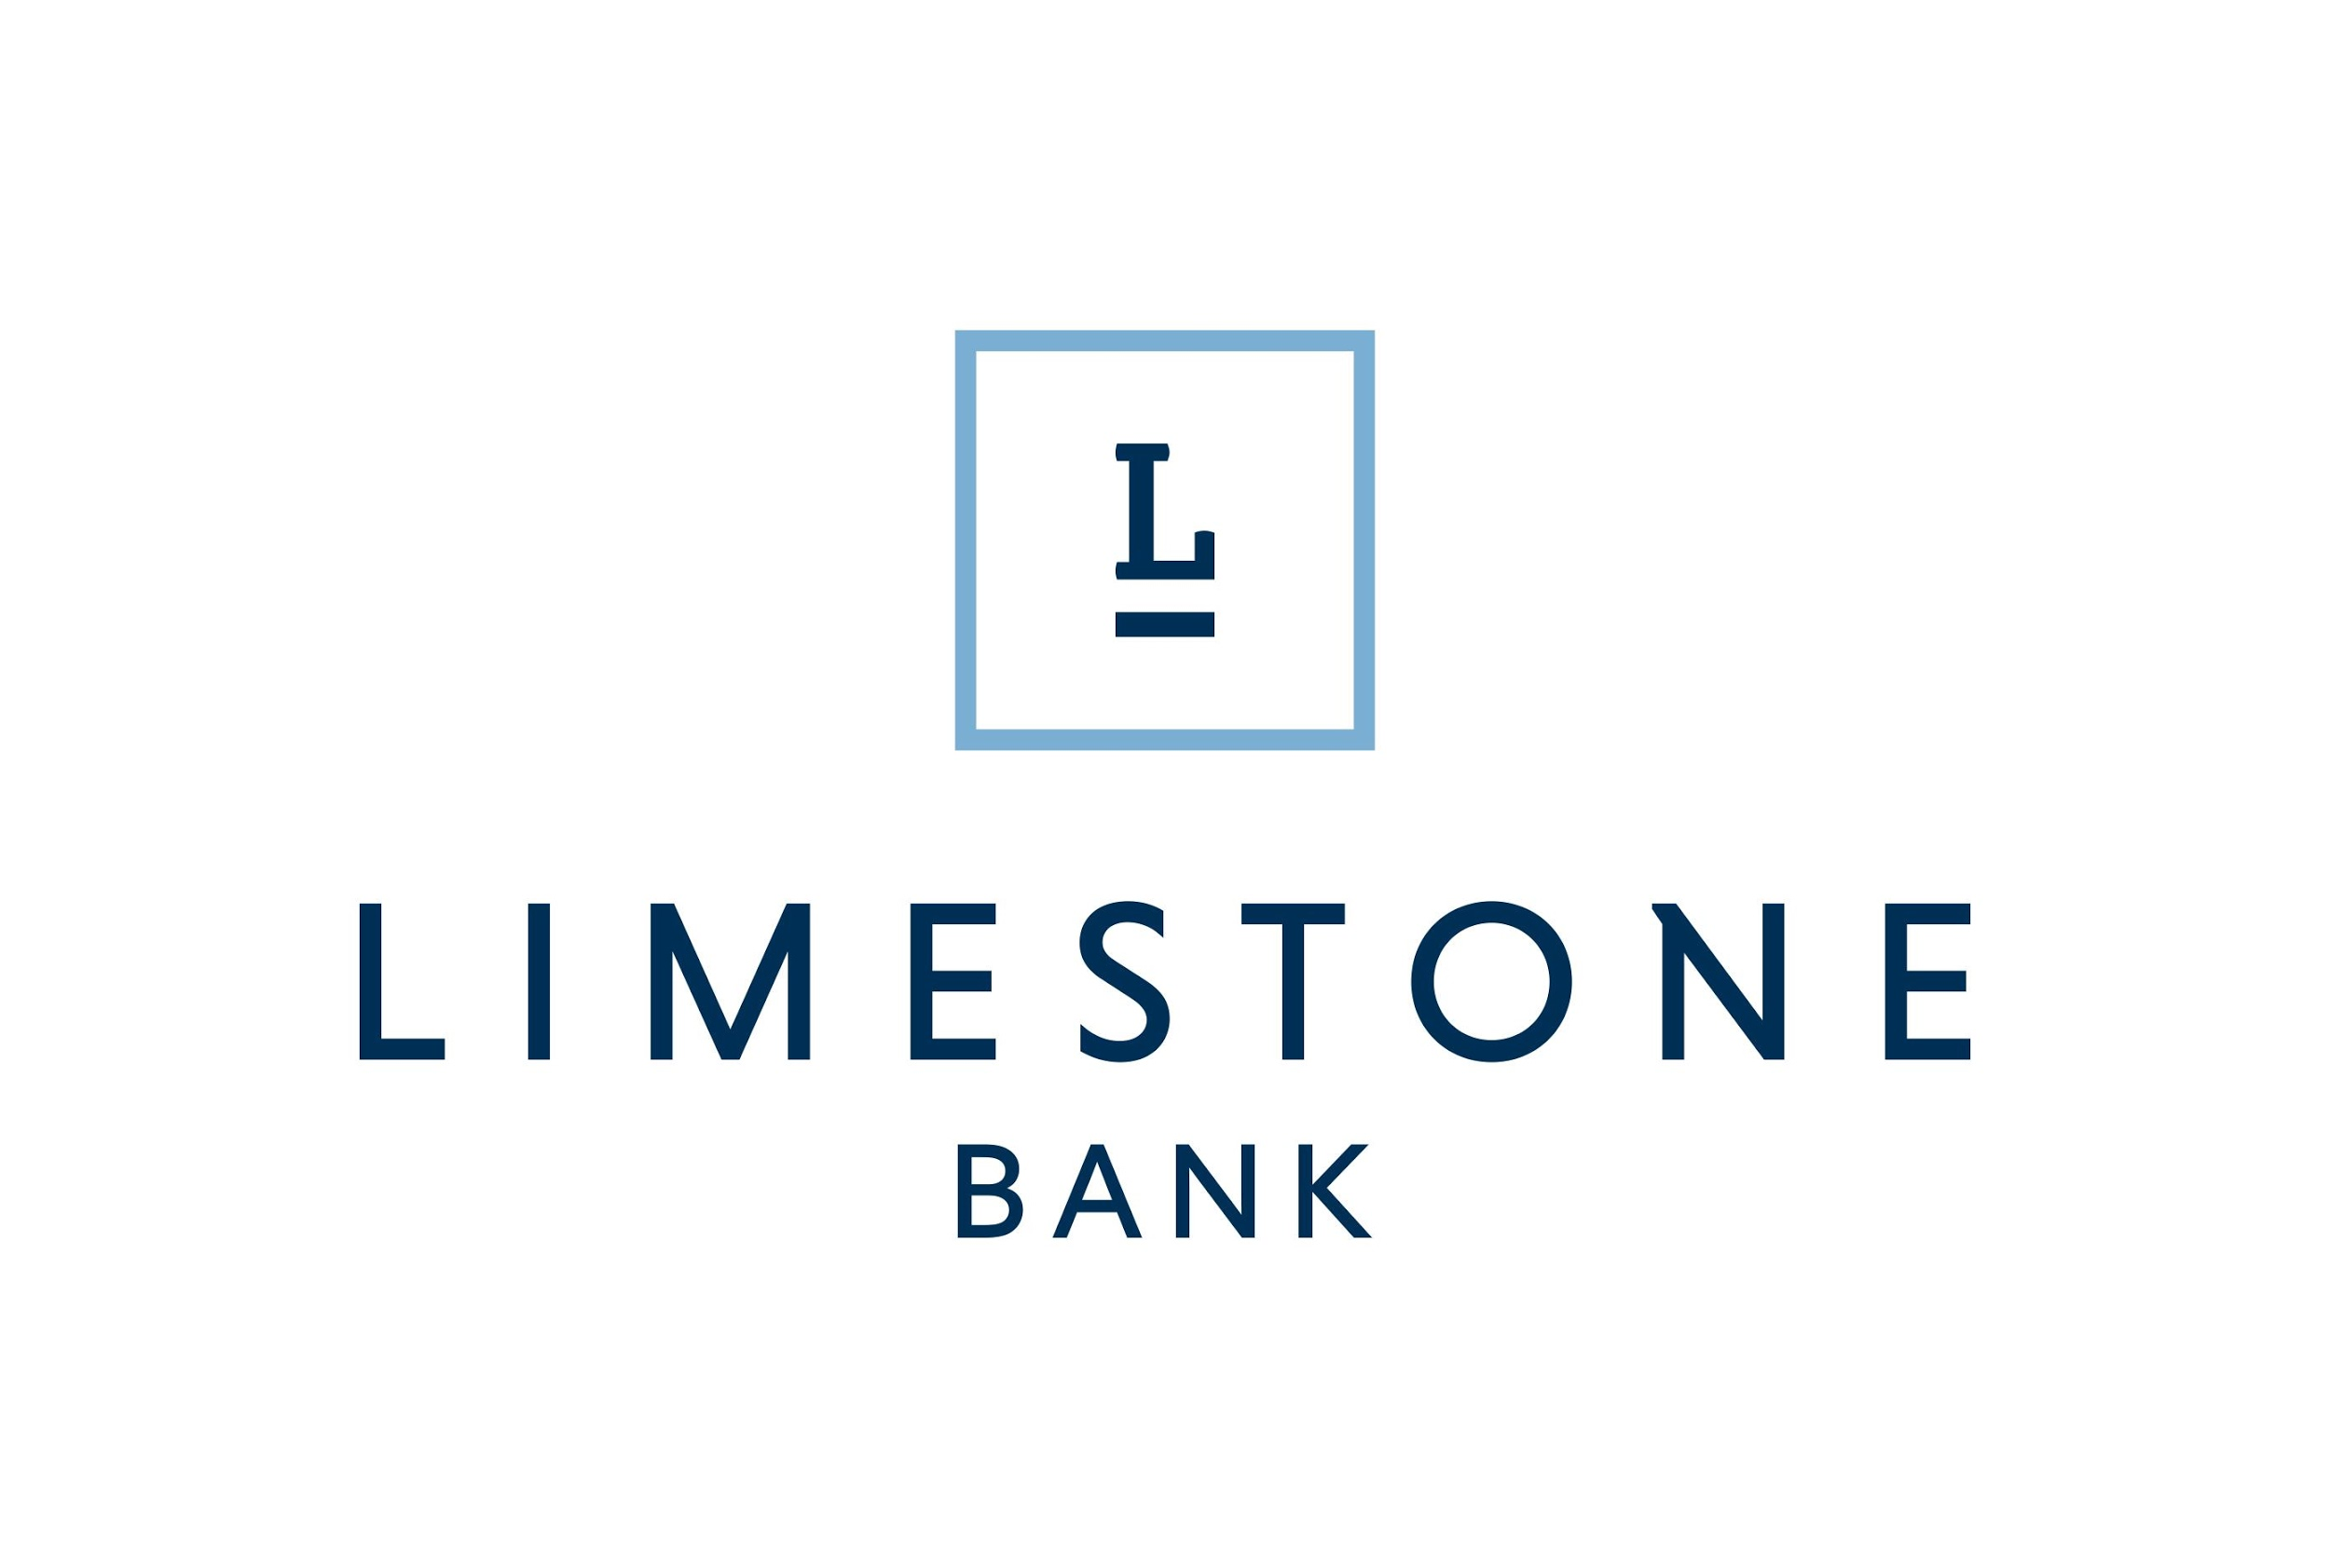

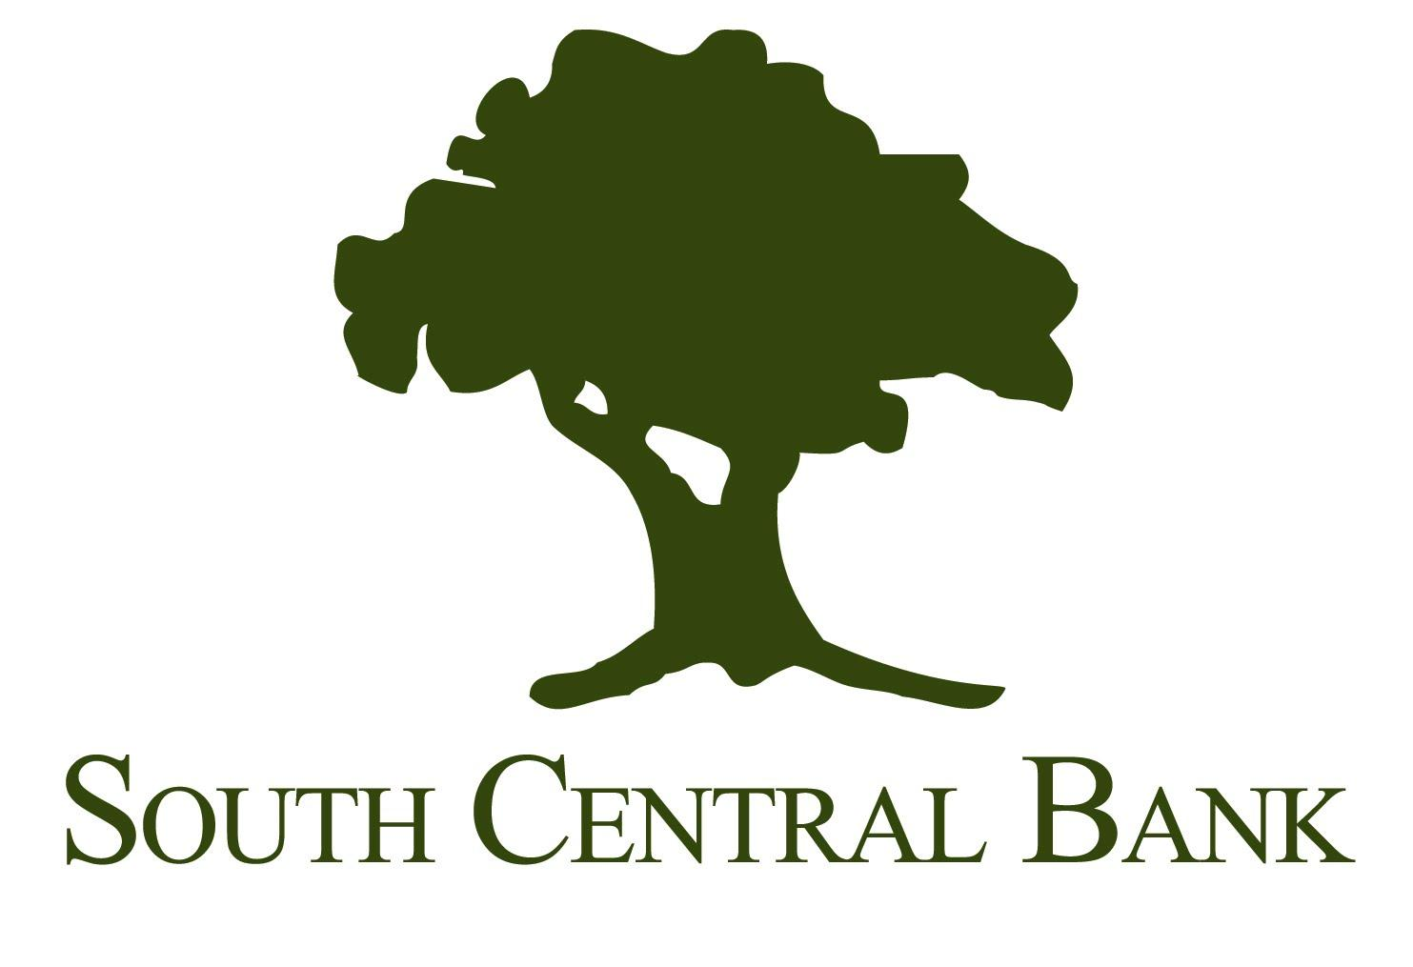
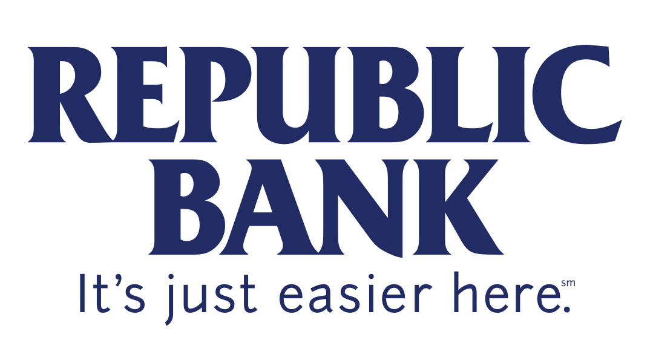

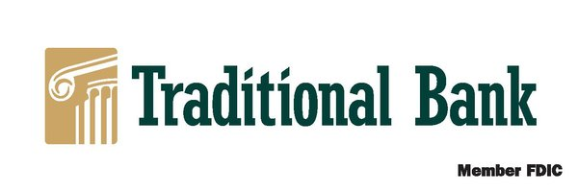

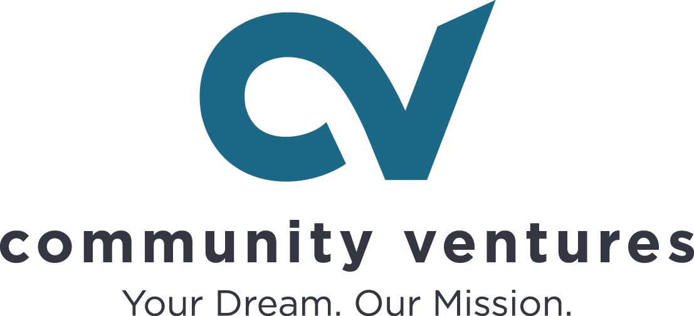

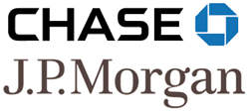

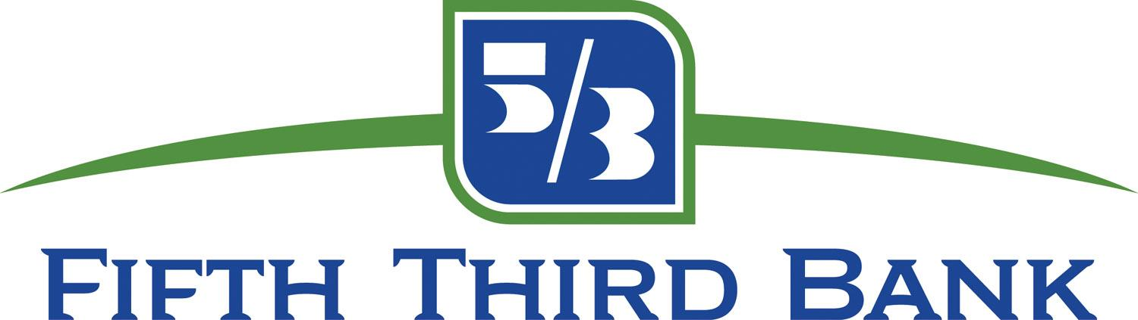

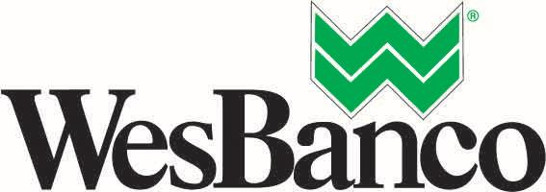
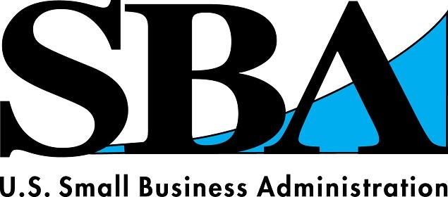
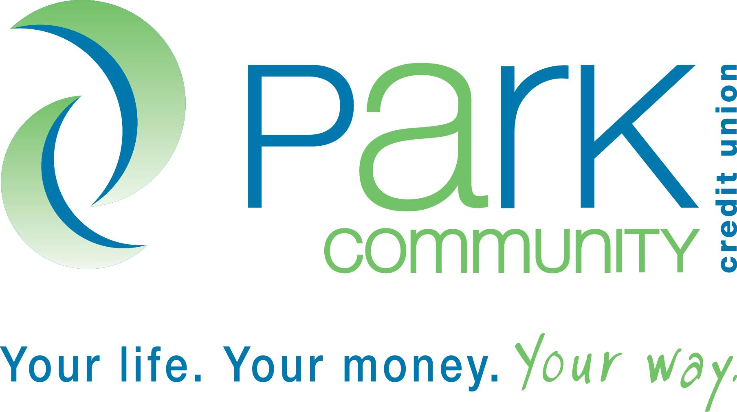

Review Data Sheet
 |  |  |  |  |  |  |  |  | Date:
Company Name:
Owner:
Ethnic Background (please circle):
- American Indian or Alaskan Native
- African American
- Caucasian
- Hispanic
- Asian or Pacific Islander
- Arab
- Other ______________________________
Sex: (please circle) |  |  |  |  |  | Male |  |  |  |  | Female |  |  | Age:
Business Address:
Home Address:
Business Telephone: |  |  |  |  |  |  |  |  |  |  |  |  | Home Telephone:
Date Business Started: |  |  |  |  |  |  |  |  |  |  |  | Number of Employees:
Type of Business:
Purpose of Loan (please circle) |  |  |  |  |  |  |  |  |  | Business Expansion |  |  |  |  | Start Up
Amount Requested: |  |  | $
Collateral To Be Pledged:

